1. Logo image :

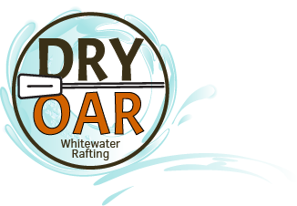

1. Color labels selected

Primary-color: 37e6d7

Secondary color: 076ab5

Accent 1-color: f8ff39

Accent 2-Color : a00008

1. Typography

Heading-font: Noto Serif

Text-font: Open Sans

1. Color pallet:

<https://coolors.co/37e6d7-076ab5-f8ff39-a00008>